HSE Monthly Report – August 2026
Weyland Energy – all sites
Hannah Weber · 07 September 2026 · HSE-RPT-2026-08

1. Headlines
Offshore substation topside installed on 19 August – a critical lift completed without incident. Contractor audit of Atlas Marine Contractors closed 4 of 6 actions from the June audit. One minor hydraulic oil leak on a jack-up leg, contained on deck.
Indicator | August | YTD 2026 | 2025
Hours worked | 294,000 | 1,755,000 | 1,452,000
Lost time injuries | 0 | 1 | 2
Recordable injuries | 1 | 7 | 6
First aid cases | 7 | 45 | –
Near misses | 41 | 276 | 307
Safety observations | 331 | – | –
LTIFR rolling 12 months | 0.88 | – | 1.38
TRIR rolling 12 months | 3.96 | – | 4.13

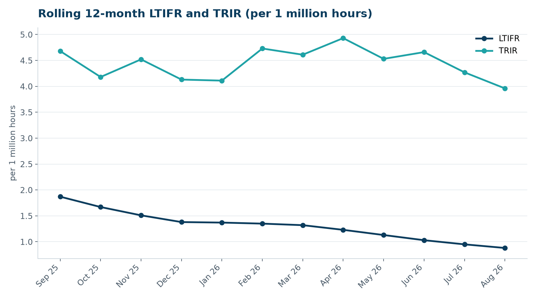

2. Hours by group
Group | Hours | Share
Weyland employees | 63,000 | 21 %
O&M contractors (operating assets) | 40,000 | 14 %
Harrow Bay contractors | 191,000 | 65 %

3. Leading indicators
- Toolbox talks delivered: 145
- Management safety walks: 14 (target 12)
- Inspections of lifting equipment: 75
- Open corrective actions older than 30 days: 7

4. Focus for next month
Preparing for the ice season at the onshore wind farms and winter driving.
Hannah Weber, HSE Manager

